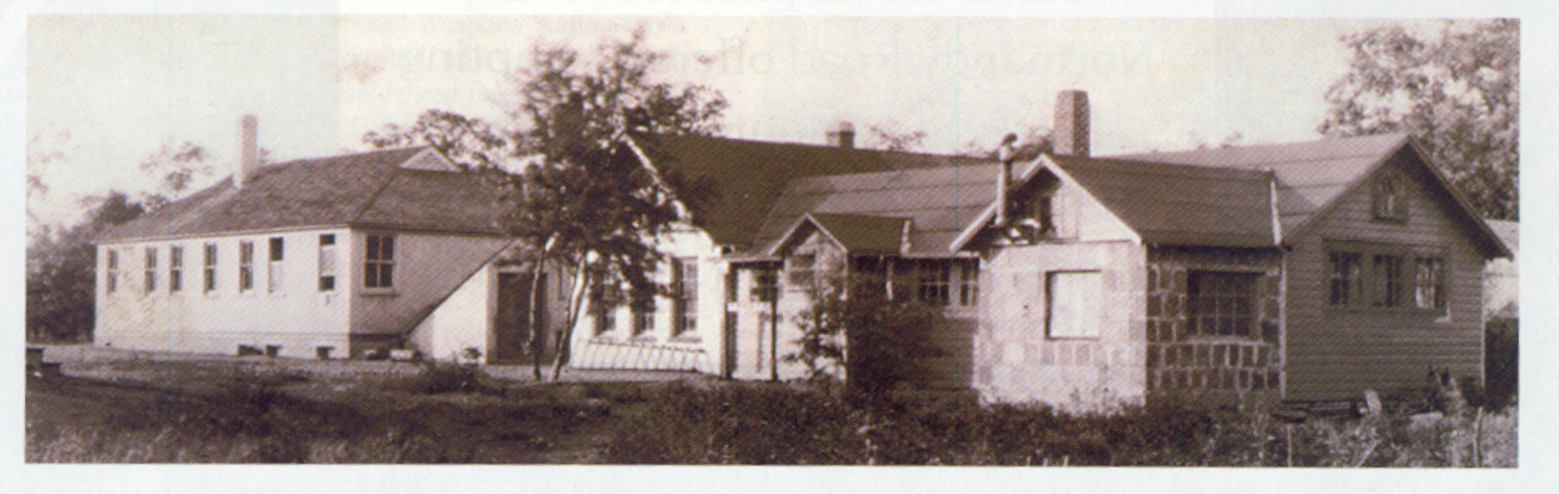

Stelton

Transcript

Intro Music: John McCutchin Backside of Albany/Cooley’s Reel.

Jon Scott - "It was... just a wonderful place to grow up. Everybody was friendly and nobody locked any doors"

Bill Giacoloni - "I remember exactly how it looked room by room. I could draw a picture of it.”

Leonard Rico - "It was a community where I really wasn't aware of ethnic differences or economic differences in a way that although we were extremely, extremely poor that I never really felt extremely poor.

Music fade out on 5 sec

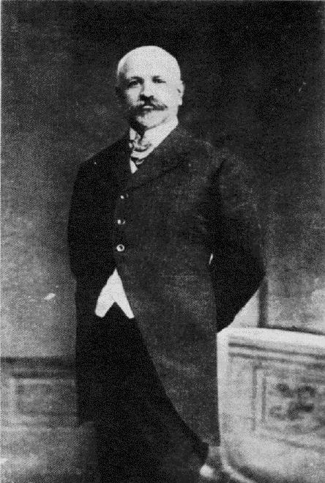
Fernanda Perrone - "In 1909, Francisco Ferrer who was a Spanish anarchist/educator was assassinated in Bacelona. He had founded the first Modern School, the Escuela Moderna which was in Bacelona and he was also an anarchist and an agitator. He was accused of being involved in an assassination attempt."

Jon Scott - "There was a charge against Ferrer in I ah, I believe it was 1909. He had tried to start a rebellion against the king which wasn't really true. He was sort of interested in it I'm sure, but he wasn't the person that did it. They found him guilty and executed him."

Fernanda Perone - "After his death there was an international outcry and Modern Schools were founded in his memory throughout the world.

Jon Scott - "In 1909 Berkman and Goldman, guy by the name of Harry Kelly, and several other relatively well known anarchists in the New York City area; started this Ferrer association. There were about twenty schools in the United States and many more in other countries that started because of the execution of Ferrer."

Fernanda Perrone - "The Modern School of Stelton, New Jersey was originally in New York City. It was the Modern School of New York. Emma Goldman and Alexander Berkmann were among the founders."

Jon Scott - Four anarchists were killed making a bomb. I believe they were gonna bomb Rockefeller's Estate. It was fairly famous. They never succeeded because they got killed making the bomb.

Fernanda Perrone - "There was and explosion in a building on Lexington Avenue. Several people who were associated with the Modern School - not so much associated with the children, but with their adult, evening... it was also a center in New York, for umm, adult education and also for performances and art classes and a lot of anarchist leaders and followers hung out there. There were three people who were making a bomb in an apartment building and blew themselves up and they were found to be people who were associated with the modern school. The police started investigating the school and so the leaders decided to move to New Jersey, it would be a better environment for the children.

Jon Scott - "The people that were running the school said let's get out of New York, it's not the right environment. And so they bought sixty or seventy acres of a farm in Stelton and sold plots to people who wanted to bring their children to the school."

Intro Car noise

Jon Scott - "So we would walk... probably to this light. Well, the light wasn't there at the time. This was, I think, Foresgates (sp?) Farms. It was a big dairy farm. It must have not died till very recently. And the little stream that I lived on is right here... this is Brookside, yup."

(Auto blinker noise)

Jon Scott - "This was part of the original colony, right here, Brookside. There was a turkish bath on the left hand side here which was deteriorating at the time we were kids. Now most of these houses are new, but I can point out some of the old ones, like that's one of the old houses. And of course this one here. That would be an original house and that one - you can see there's a certain style to them. But now that one there probably was... and most of these are new."

Bill Giacoloni - "There was a man made pool on the acreage. When I say man-made, they damned up a brook that went through. The Ambrose Brook. We used to swim there, as children and then we used to ice skate there, and we used to ice skate on lake Nelson which was just a half a mile away. We used to go on nature walks. We would sometimes attend classes in the nice weather outside. The teacher would just talk about maybe something in nature. Or we would sing songs and each one had either a tambourine or a cymbal or a drum or something and we would accompany them. We would go to the carpenter's shop. There was the metal shop, there was the weaving shop, where they had three beautiful looms. There was the art shop, there was the library... and there was the great outdoors. Or the print shop where we would set our own type and print our own woodblocks. Every once a year we put together a children's book, which we all printed."

David Freedman - "We started the Voice of the Children which was a magazine done by the children completely. We did learn to type-set and to print. A older kid would take dictation from one of the younger kids for stories and then we made prints for pictures on linoleum... ah, linoleum cuts and added those into the things... and it was quite well known. I mean everybody, people in New York, everybody knew about the Voice of the Children books. There's still collections because we used to come out with one most every year - with poetry and stories and so on from kids four, five, six, all the way up to thirteen or fourteen before the kids went to high school."

Bill Giacoloni - "I remember the first piece I had in Children's Voice. I didn't set the type. Lola... Kenner, who was a little older, wrote down what I said, and my story was: 'Once there was a cat who lived in the forest.' Willy, age five. (Laughs) And that was it! And it got printed."

Leonard Rico - "My dad had spent some time raising money in the defense of Sacco and Vanzetti. Ah, he had worked to organize unions. They both, of course were working-class immigrants. They had little if any formal education. The community also had a cooperative dress factory. Everybody who was involved with it... were the owners. Both my parents were in the needle trades - my father was a presser, and my mother was a power machine operator. The radical orientation of this community, encompassing socialists, anarchists, communists, ah, cooperatives, well who knows what; plus this environment of establishing a school - it attracted people who were interested in the labour movement, interested in creating schools to educate the (fade out begins) students in a different way.

Jon Scott - "Now Ferrer believed in um... freedom in education. The reason he believed that is that you can only truly be free if you've been free as a kid. And you must learn freedom with responsibility, along with the idea that you're free, to choose. And he was very much against the kind of schools that we have today and the kinds they had at that time where you sit in class and you do what you're told and you learn discipline. His idea of discipline was that you learned responsibility along with the freedom that you're given. That was the main pedagogical idea of the Modern Schools. You could never have a truly anarchistic society if children are brought up without freedom.

Bill Giacoloni - "This is the way the morning started. We would arrive in the auditorium. Maybe it was eight o'clock, maybe it was nine o'clock. And in many cases somebody played the piano, and we would sing songs and welcome each other. And we would play little games, and then the last thing we would do, which we called "the snail" we would sing a goodbye song and go into this inter-winding snail and come out of it and then go to our classrooms.

Jon Scott - "There were no classes in the school. The only place there was a blackboard was in the art room and we used to play hangman and games like that on the black board, or tick-tack-toe. We attended a morning meeting. We sang songs and planned our day a little bit. And after that morning meeting at nine o'clock you didn't have to report anywhere. So you could go sled riding, or play sports or play games. The school had an art room, a weaving room; arts and crafts were emphasized. There was a kindergarten with all kinds of different blocks and toys that you could build things with. One of the teachers - Elizabeth Ferm was a follower of Frederick Froebel, who was the father of the kindergarten and the kindergarten was a school like the Modern School. All ages attended the school, there were no age groupings. There were no tests, no exams...

Leonard Rico - "The school itself was highly unstructured. About the only structure that I remember was the meetings in the morning when all the students sat around in a circle and did certain exercises or dances or we had discussions. Other than that it was basically what ever your interest was you indulged it. There was a carpenter shop, a printing shop. A art room, a weaving room, a play room, an auditorium and of course the outside. So that you could do whatever you pleased and engage in artwork or making something in the shop or composing something and printing it and so on. Or, if you wanted you could go swimming, you could play outside... whatever. The people who are somewhat older than I had a vastly different educational experience. There were more students there, there were more structured educational experiences in terms of studying or learning in a more formal way.
I had no formal education. I enjoyed working with my hands, I enjoyed the activities. I still enjoy doing things with my hands and it's been a life-long legacy...

Jon Scott - "I did not learn how to read until I was, oh, probably nine-and-a-half. I didn't see the need for reading. Anybody could learn to read if they wanted to. All they had to do was to ask the reading teacher who happened to be my mother. She was almost never busy because hardly anybody wanted to learn how to read - until they wanted to learn, and I wanted to read the comic books. I wanted to read Captain Marvel, and Superman and Dick Tracy. And so I went to my mother and I said I'd like to learn how to read. She says 'okay, here's a book.' And she gave me a book of poetry. Children's poetry. And she said well, start with this one. Of course she picked out a poem that I knew by heart anyway. And so than I could associate the words with what I remembered.

Fernanda Perrone - "It was very informal. Although they did have meals - some children were boarding there, and other children were living in the community, so would have meals at home. Basically there were a number of different activities going on at the same time, and children could choose which they wanted to do. It varied though, according to who was the principal and who was teaching. When Elizabeth Ferm was principal, they had an assembly in the morning where everyone got together. After that children could disperse to the activity that they wanted.
Jim Dick, Little Jim's father, taught more academic subjects like English, Literature, Geography and other subjects. There were other people who taught the more academic subjects.

Jon Scott - "For the remainder of the day I could do anything I wanted. I became a world-class kick the can player. I spent an awful lot of time both winter and summer on Ambrose Brook. We used to catch suckers and sell them to the residents of the community for five cents each. (Laughs) ...if we could get them. We always caught more than we could sell. As a matter of fact we played Monopoly once and a while - we never played it at school, we always played it at someone's house. I was a good marble player. I remember buying a five-cent bag of marbles and building it up to an oatmeal box full of marbles. So I became a marble capitalist for a while. But we'd hike. There were organized hikes, overnight hikes into the nearby hills - the Watchon Mountains they were called. They were about one-fifth the size of the Heldeburgs over here... they really weren't mountains.
We used to walk into New Brunswick which was about three miles away and play in the park there. You could take a bus to New Brunswick and go to the movies, and we used to go sneak into the Rutgers football games. Behind the clock you'd see about ten little kids looking at the football game from behind the clock in the end zone.
There was a print shop, a ceramic studio. A woodshop, metalworking - we used to make ashtrays and things like that to sell for the school, and we'd sell our weavings.
I spent quite a bit of time in the wood shop, but actually mostly outside. There were no programmed classes in any sense other than the hikes that we used to take. I learned to print on the print press, and I learned to set type before I could read. So I dictated a poem to one of the older students and she wrote it down and I went to the print shop and set the type and printed it up on the little printing press.
Saturday there was often a dinner or a meeting to talk about the school. Plays that the students would present. I played Touchstone in As You Like It. And we would give little plays based upon the nursery books, you know the little stories. One teacher would read to us from these books, you know Billy Goat Gruff, Red Riding Hood, and you name them all...

Leonard Rico - "One of I think the unique features was the relationship between students and teachers. Since there were no classes or grades, you didn't change teachers either. So that there was a long association. I have very good memories of several teachers I'm particularly fond of because of their kindnesses and their understanding of me.

Bob Vinik - "Probably the most influential person in the school for me was Uncle. Uncle Ferm was a tremendous guy. I remember somebody was talking about the "wild man from Borneo," and I turned around to Uncle and I said "where's Borneo, what's Borneo?" Uncle had a Boling Ball that he had sandpapered rough. And he held it up in one hand and with the other he took a piece of chalk and he drew the world on it. And that day I not only learned where Borneo is, but I also learned the difference between following the latitudes and Great Circle sailing.
He was a remarkable guy who influenced a lot of people. One of the things that Uncle told me is that any radical who wants to change the world must have one of these as he fondly pointed to his printing press. (Laughs). He had an old hand-fed press, and we had to put in one piece of paper at a time and he taught me to run the press and he taught me it's importance.
"Today of course, we have copy machines and computers, but basically it's the same philosophy. We must be able to tell the world what it is we want them to know about us.

Fernanda Perrone - "Alexis and Elizabeth Ferm who were principals of the school in the early days and then came back in the thirties. Elizabeth died and Alexis remained principal until about 1950 when he retired. They were pioneers in free education. They had founded their own school on the lower east side before coming to the modern school. Elizabeth Ferm had studied with Froebel, the founder of the kindergarten movement, which she used at the Modern School and it was quite revolutionary at the time. To have children playing freely as in a nursery school today, for example. Elizabeth wrote a number of articles and a book about her theories. In some ways she was a difficult character. She had been educated in a convent school. In some ways she was a Victorian woman in spite of her radical ideas.
"Her husband, Alexis, he was sort of universally beloved. He was much more easy-going person. The Ferms as far as education had a very hands-off method, as far as really let the children do what they want.
"The Dicks had a slightly more traditional, more structured effort. They were probably as influential as the Ferms. They were from England and they had a school in England and another school in New York. They were similar in that they had been involved in other free schools before coming to Stelton. They made their living through education. They left the Modern School and taught at the school in Mohegan, in upstate New York. They came back to the modern school. Eventually they left and founded another school in Lakewood.

Leonard Rico - "The kinds of values: independence, creativity that I think are part of my heritage from being part of this community and it's school. The community itself is very diverse, all kinds of ideological positions. The dynamics, the debates, and the confrontations between the various ideological positions and so on, I think is sort of an interesting intellectual background. Deciding my activities and what my interests were has had a lasting impact in terms of the kind of person I am now. And I think in terms of the values, of respecting differences, respecting other people, values that were essentially non-competitive, non-materialistic; has had a great effect on my life.
So, my reactions are mixed. I felt that as a person it's had a unique and immense impact on me as a person, but I still even now that I'm retired, wake up some nights in this cold sweat anticipating my exams in statistics.

Bob Vinik - "Looking back at the history of the school, it was in 1914 when Will Durant was the first leader of the school. The school was organized in New York City and he decided 'we're moving to the country,' and they moved to a place called Stelton which was very rural. The township of Piscataway had 1,500 people living in it at the time. What happened later on was, the township of Piscataway became a suburb of New York City. Same problem existed, but everybody now had investments in real estate. Schools, jobs... they weren't ready to move again. The school was adjacent to the fence that bordered Camp Kilmer. It was more than just the Camp. It was the presence of the Camp, the presence of all of the housing developments that were all around us, the building up of the neighborhood and the community; the fact that New Brunswick which was a sleepy little college town became an industrial town as well. Too much outside influence. Some of which was less than pleasant.

Jon Scott - "The school kept going until 1953 after Alexis left. But, you know, there were only ten or fewer students in the last years. Some people say it was the Camp Kilmer that caused the school to decline. I think perhaps another reason was that socialism became a lot more interesting to a lot of people than anarchism. The children had grown up. Some of the people of the community stayed there, but they didn't have any children. So there really wasn't any room for other children, and the school didn't make a big deal about trying to keep it going. There wasn't really another Alexis and Elizabeth Ferm. It was mostly, people didn't really feel that it needed to go on. There was no thrust. It was... the anarchists were there and they wanted their kids to go to the school, and they had grown up. And there were no more anarchists.
I think Communism and Socialism took over a lot of the anarchists, and there was no source to tap.

David Freedman - "You had a lot of different political opinions in the community. The largest group initially were the anarchists, but we had Communists, Trotskyites, IWW people, Lovestonites, Shackmanites, and across the main road there were Socialists, and there were several sectors of Socialists that lived on the Fellowship Farm which was on the other side of the Colony Community.

Bob Vinik - "The school was a building. The people there, are basically ordinary people who have many philosophies, some of whom were very rigid and some of whom were very flexible. There were always discussions between the Socialists and the Democrats and the Communists and the... everybody else. One of the major, big discussions was weather we should indoctrinate the kids, because the communists felt that we should teach Communism to the kids. And the other folks said, 'lets not teach them anything and let them decide what they want to be. And of course then the other guy said, 'well if you are going to teach them Communism, we want to teach them to be Democrats or Republicans or Socialists or whatever else... and why don't we teach religion while we're at it? And of course everybody threw up their hands at that.

Leonard Rico - "I stayed in the community through college, and then when I graduated college I moved out. By that time the community was undergoing tremendous transformation as new people moved in and diluted the older people's influence, and certainly the school essentially disappeared. The shop disappeared, and the identity of the community disappeared as well.
"During the 40's there was the military presence and there may have been some negative experiences that some of the people in the community experienced as a result; but I don't see that as the major force. I think the major transformation was that the children of the original settlers, and the children's children acclimated to the mainstream of American society. They weren't imbued with the same motivations as the original settles. People just blended in with the general population. Which is not to say that I don't feel that there were positive things and influences that I feel are part of me and will always be part of me. In Stelton there was always this tug-of-war between yes freedom and choice, but there were always these intellectual battles over which was better and which was not. Sometimes between ideological groups there was very little tolerance.

Jon Scott - "The board of the Ferrer association held a final meeting and sold the land. There were people in the nearby communities that thought of the colony as something evil and bad, you know a bunch of kids running around naked; and there's some truth in that. A lot of the kids would run around naked a little bit... they got some pictures of me running around naked. But that was minor.
"I don't think McCarthy-ism had anything to do with it, I don't think the FBI was interested in closing the school. They were just finding out what was going on, and they were probably finding out that there was nothing important going on... it was just a group of people interested in an idea.

INTRO MUSIC: John McCutchin Back Side of Albany/Cooley’s Reel.

Bob Vinik - "The School taught me the one thing that I really needed to know in order to survive and excel in life, and that was how to learn. They taught me that I could learn anything, and I didn't need a formal, constrained program of education. That I could search and inquire and learn almost anything.

Bill Giacoloni - "I just, when I think of the whole time I was there, even though it was a time in my life when I was unhappy, I would have been worse-unhappy somewhere else, because it was really a wonder place to be. We had friends all over the place, you know, everybody knew everybody, we were kids together, we had open fields... It was like heaven. And, you know, as we got older, things became more complicated. Oh, I think back and it was... oh, I wish my kids could have had some of that.

